Project Design Phase-II
Technology Stack (Architecture & Stack)
Date | 28-10-2026
Team ID | SWUID2026402568
Project Name | HotelPro - Complete hotel booking and management solution
Maximum Marks | 4 Marks

Technical Architecture:
The HotelPro platform is designed with a scalable 3-tier architecture that includes the presentation layer (frontend), business logic (backend API), and data storage layer. The solution ensures optimal performance, strict security, and seamless integration with essential third-party services (e.g., Stripe/Razorpay for payment processing and Nodemailer for notification delivery).

Table-1 : Components & Technologies:
S.No | Component | Description | Technology
1 | User Interface | Web-based responsive portal for guests to view & book rooms | React.js, HTML5, CSS3, Bootstrap
2 | Application Logic-1 | Room inventory, booking engine, price calculation & user profiles | Node.js, Express.js
3 | Application Logic-2 | Staff administration, housekeeping tracking, report generation & security middleware | Node.js, Express.js, JWT
4 | Database | Stores user accounts, room categories, booking transactions & bills | MongoDB / MySQL

Table-2: Application Characteristics:
S.No | Characteristics | Description | Technology
1 | Open-Source Frameworks | Modern UI libraries and backend execution framework | React.js, Node.js, Express.js, Bootstrap
2 | Scalable Architecture | 3-tier microservice-ready design with RESTful API architecture | MVC Architecture, RESTful Services

Technology Stack & Architecture Flow Diagram:
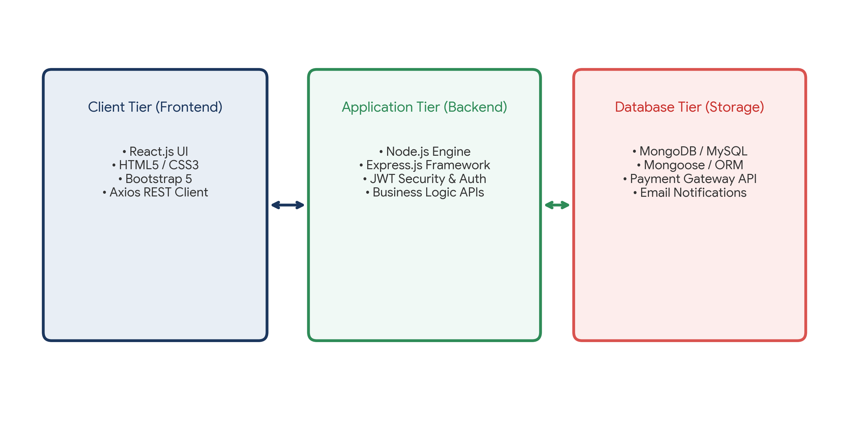
References:
- React.js Documentation: https://react.dev/
- Node.js Best Practices & Architecture Guide
- Express.js Routing and Middleware Reference
- MongoDB / MySQL Integration & Security Standards

